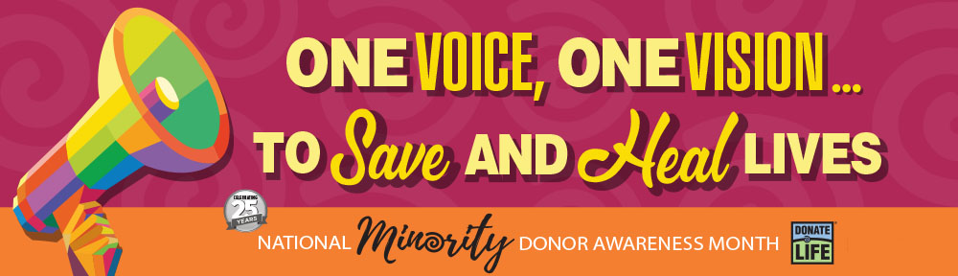
The need for minority organ, eye and tissue donors is critical.
Learn the facts and register today to help save and heal more lives.

The need for minority organ, eye and tissue donors is critical. Nearly 60% of the more than 100,000 men, women and children waiting for lifesaving organ transplants in the U.S. are from minority communities. Here in Illinois, nearly 4,000 people are waiting—and more than 60% are people of color.
August is National Minority Donor Awareness Month, now in its 25th year. [INSERT ORGANIZATION NAME] joins Gift of Hope Organ & Tissue Donor Network and communities throughout Illinois to share the facts about the need and the important decision to register as a life-giving donor.
Why is registering as an organ, eye and tissue donor so important?
A variety of health conditions disproportionately affect minority communities, including chronic kidney disease. These illnesses can lead to need for organ transplants. Although transplants can be successful regardless of the race or ethnicity of the donor and recipient, the chance of longer-term survival may be greater if the donor and recipient share a similar genetic background. To give everyone waiting for organ transplants better opportunities for a second chance at life, it is critical for minorities to register as donors.
Sadly, the need for organ transplants far outpaces the number of organs available for donation. On average, 20 people die every day waiting for a lifesaving transplant and every 10 minutes a new person is added to the national waiting list.
You can help save and heal more lives
Together, we are one voice moving toward one vision: to save and heal more lives. One donor can save up to eight lives, restore sight in up to two people through eye donation and heal more than 25 people through tissue donation.
Learn the facts about the donation process at giftofhope.org and register your decision to save and heal lives as an organ, eye and tissue donor today. Get started at bit.ly/GOHRegister or by texting HOPE to 51555. Remember to share your wishes with family and friends.

