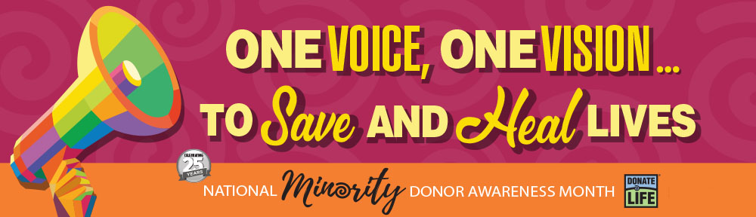
The need for minority organ, eye and tissue donors is critical.
Learn the facts and register today to help save and heal more lives.

The need for minority organ, eye and tissue donors is critical. Nearly 60% of men, women and children waiting for lifesaving organ transplants are from minority communities—disproportionately affected by chronic kidney disease, diabetes and heart disease and other conditions that can lead to the need for an organ transplant.
August is National Minority Donor Awareness Month. [INSERT ORGANIZATION NAME] joins Gift of Hope Organ & Tissue Donor Network and communities throughout Illinois and Indiana to share the facts about the urgent need and the important decision to register as a life-giving donor.
- Compatible blood types and tissue markers—critical qualities for donor/recipient matching—are more likely to be found among members of the same ethnicity.
- A greater diversity of donors can increase access to transplantation for everyone.
- The chance of longer-term survival also may be greater if the donor and recipient share a similar genetic background.
Saying yes to being an organ and tissue donor means the world to those waiting for a chance at life. One donor can save up to eight lives, restore sight in up to two people through eye donation and heal more than 25 people through tissue donation.
Understand organ & tissue donation. Register as a donor. Talk to your family today.
Together, we are one voice moving toward one vision: to save and heal more lives.
Learn more and register your decision save lives at giftofhope.org.

